
Project Tile :
Einstein-Cardozo Bioethics Graduate Education Website
Overview of Project :
Alex will design, develop and deliver the Einstein-Cardozo Bioethics Graduate’s online presence. This will be accomplished by strategically designing a fast, clean and responsive website that the will showcase necessary content while remaining true to the brand’s identity. Using Wordpress, a proven content management system, the client will be able to upload, modify, and change content on the fly.

Deliverables:

- Website Design and Development
- SEO Implementation & Google Analytics Tracking
- Hosting, Backups, Security Maintenance
- Social Media Automation
- Class Registration System
- Event and Calendar Registration System
- News and Events Section
- A Mobile Responsive Design that will work on any screen

Costs:

Labor Cost : 2.5K <> 3K (Depending on agreed scope)
Utilities Cost
- Hosting : est 100-120 - per year
- Domain Registration : est 10-30 per year
- Wordpress Assets & Plugins : 85
Payment Schedule:
Upon Draft 1 : 50% of total labor cost
Upon Hard Launch : 50% of total labor cost

Timeline:
After Proposed Start Date:
Soft Launch : 4 weeks
Hard Launch : 2 weeks after

A note on labor :
- Labor includes the above deliverables including 2 rounds of revisions and basic website maintenance. Any additional feature, page, design, etc - will be done on the hourly basis @ $40 an hour.
- Labor also includes training with the client and owner of how to use and operate the website.

Recent Work:

- https://nyjdi.com/
- http://ehospitalitynyc.com/
- https://firstviewfinancial.com/
- http://brfries.com/
- http://laramichelle.com/
- https://www.1105main.net/
- https://hvandpartners.com/
- https://lalibrairiedesenfants.nyc/

Alex Gonzalez
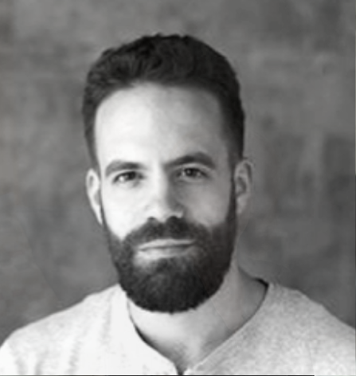
Alex is a writer, filmmaker, web and virtual reality developer. He travels to schools across the tri-state area and teaches students how to get started in VR and web development, including how to brainstorm, code, and rapidly iterate ideas into practice. With a primary focus on storytelling, Alex has led dozens of students from imagination to project completion. He is the founder of the New Haven VR Developer Group and his debut VR film ‘Beyond the Mountain’ premiered last year at the Jacob Burns Film Center and was the first VR film to be accepted into the MIddlebury Film Festival.

On the web front, Alex has worked with various brand agencies for the greater part of 15 years. Taking client’s visions and turning them into realities, Alex has designed and developed dozens upon dozens of websites and online campaigns. Having served as a senior developer for the award winning design agency CreateCR, has collaboratively worked with companies big and small to bring their online strategies to fruition. When not developing, Alex enjoys writing poems, narrative fiction, playing Flamenco guitar, wrestling, painting and wandering through the woods.

